**Parallel and distributed system**

**Mir Hussain**

**Task1:**

Create a Docker image based on the Alpine Linux image, and then run a container using this image. Modify a file inside the container, and then use docker diff command to see the changes there were made. Write a brief report on your findings. And send that report along with screenshot of the command.

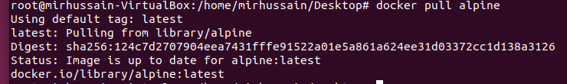

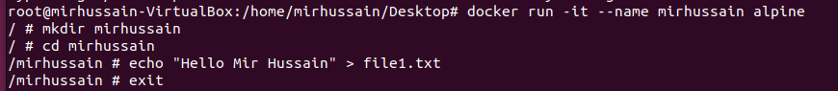

I have pull the alpine image and run the alpine under the mirhussain docker and the created a directory and inside directory created a file named as file1.txt and modify it

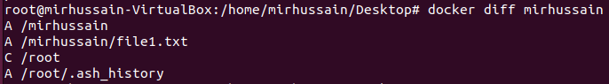

**Task 2:**

Create a docker container from an image of your choice and start the container. Use the docker attach command to enter the running container and make some changes such as installing new software or modifying configuration files.





